Sources

Home Prices

<https://thda.org/research-planning/home-sales-price-by-county>

Crime rates

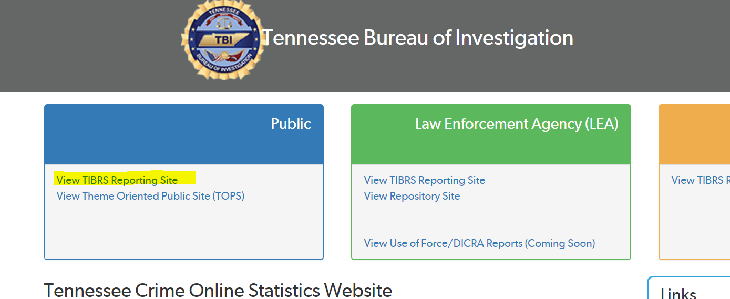

<https://crimeinsight.tbi.tn.gov/>

Bachelor’s degree as of Jan 11, 2019

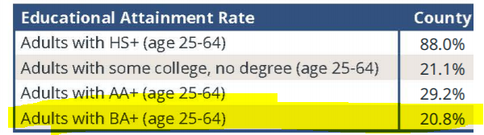

<https://www.tn.gov/thec/bureaus/planning-and-research/county-profiles.html>

Not sure if this may be helpful for you.

Demographics

<https://www.tn.gov/education/data/data-downloads.html>